See in string anagrams are those whose frequency is similar.

See in the tree we need to tell whether on each level anagram possible or not.

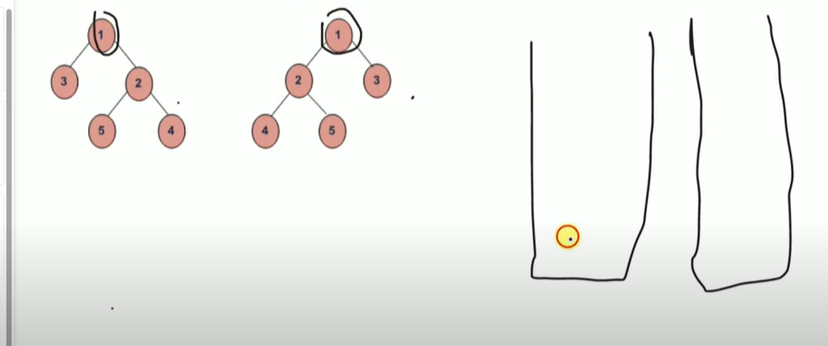

See we will take 2 queue and put both root node in the queue. This same as level order procedure.

See currently size of both queues is 1 and hence check same or not. Then run 1 time this is for left and right

See after taking left and write we will pop 1 from both queue and store it in vector and then sort them. This will allow us to check if anagram or not. Same will be done for other levels.

See no queue element left will tell this tree is anagram.

Code:

<https://github.com/Thelalitagarwal/GFG_Daily_Problem/blob/main/Check%20if%20all%20levels%20of%20two%20trees%20are%20anagrams%20or%20not.cpp>

code:

